USE CASE- View Expense SPECIFICATION

Use-case No. | UC001.1 | Use-case Version |  | 1.0
Use-case Name | View Expense
Author | LinhLLL
Date | 03/10/2012 | Priority | High
Actor:
User
Summary:
User can view monthly expense or daily expense.
Goal:
Allow user view detail expense.
Triggers
Touch management icon, first icon at the bottom of screen.
Preconditions:
Accessed to application
Post Conditions:
<List the required post-conditions for using this case>

Main Success Scenario:

Step | Actor action | System response
1 | Touch first icon at the bottom of screen | Display “Chi phí” screen includes:  - List of expense  - Add new expense icon at the top-right of screen
2 | Touch one item of list | Display sub- item of selected item
3 | Touch one sub-item | Display “Chi phí ngày” screen

Alternative Scenario:
Step | Actor action | System response
1 | Touch first icon at the bottom of screen | Display “Chi phí” screen includes:  - List of expense  - Add new expense icon at the top-right of screen
2 | Touch “Thu nhập” tab | Display “Thu nhập” screen

Step | Actor action | System response
1 | Touch first icon at the bottom of screen | Display “Chi phí” screen with content “No data”
2 | Touch “Thu nhập” tab | Display “Thu nhập” screen with content “No data”

Exceptions: N/A
Relationships:
UC 002.2, UC 002.3, UC 002.4
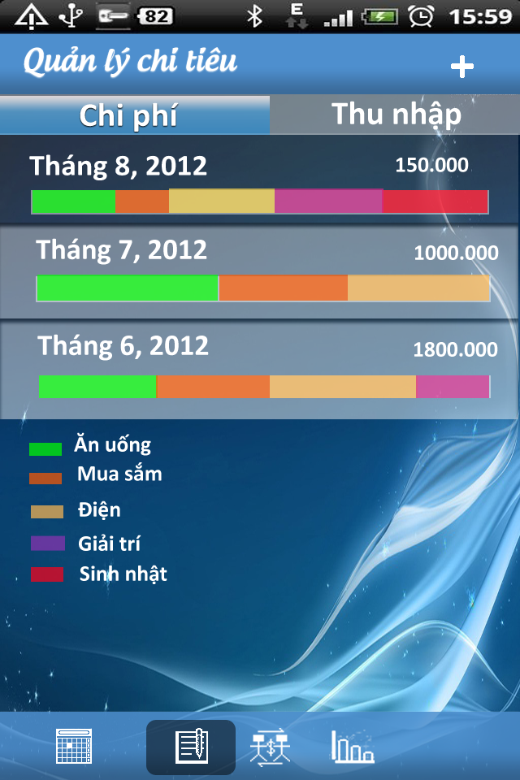
Business Rules:
No | Rule Description
1 | In order to view expense, user must accessed application
2 | In order to view detail, user must touch one item of list expense
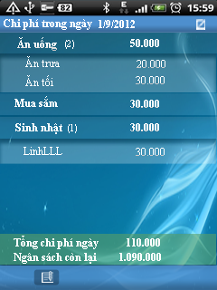
Screen:

USE CASE- Add Daily Expense or Income SPECIFICATION

Use-case No. | UC001.1 | Use-case Version |  | 1.0
Use-case Name | Add Daily Expense or Income
Author | LinhLLL
Date | 03/10/2012 | Priority | High
Actor:
User
Summary:
User can input daily expense.
Goal:
Allow user input detail expense.
Triggers
Touch management icon, first icon at the bottom of screen.
Preconditions:
Accessed to application
Post Conditions:
<List the required post-conditions for using this case>

Main Success Scenario:

Step | Actor action | System response
1 | Touch first icon at the bottom of screen | Display “Chi phí” screen
2 | Touch add new icon at the top- right concern of screen | Display “Thêm chi phí” screen
3 | Enter data into all fields | Display all entered data
4 | Touch save icon at the top- right concern of screen | - Return “Chi phí” screen  - Show message “Saved”  - Display saved data

Step | Actor action | System response
1 | Touch first icon at the bottom of screen | Display “Chi phí” screen
2 | Touch add new icon at the top- right concern of screen | Display “Thêm chi phí” screen
3 | Enter data into all fields | Display all entered data
4 | Touch cancel icon besides save icon | - Return “Chi phí” screen  - Nothing is saved

Alternative Scenario:
Step | Actor action | System response
1 | Touch first icon at the bottom of screen | Display “Chi phí” screen
2 | Touch add new icon at the top- right concern of screen | Display “Thêm chi phí” screen
3 | Touch “Chi phí” toggle | Change “Chi phí” to “Thu nhập”
4 | Enter data into all fields | Display all entered data
5 | Touch save icon at the top- right concern of screen | - Return “Chi phí” screen  - Show message “Saved”  - Display saved data

Step | Actor action | System response
1 | Touch first icon at the bottom of screen | Display “Chi phí” screen
2 | Touch add new icon at the top- right concern of screen | Display “Thêm chi phí” screen
3 | Touch first date field | Choose desired time
4 | Enter data into all remaining field | Display entered data
5 | Touch save icon | - Return “Chi phí” screen  - Show message “Saved”  - Display saved data

Exceptions:

Step | Actor action | System response
1 | Touch first icon at the bottom of screen | Display “Chi phí” screen
2 | Touch create icon at the top- right concern of screen | Display “Thêm chi phí ” screen
3 | Touch first date field | Choose desired time
4 | Enter data into all field | Display entered data  - If amount of money make total expense greater than budget:  + show message: “Chi phí này vượt quá ngân sách của bạn. Bạn muốn tăng thêm ngân sách không?”  + 2 buttons: “Có” and “Không”
5 | Touch “Có” | - Update budget and expense  - Show message: “Đã tăng ngân sách”
6 | Touch save icon | - Return “Chi phí” screen  - Show message “Saved”  - Display saved data

Relationships:
UC 001.1, UC 001.3, UC 001.4
Business Rules:
No | Rule Description
1 | In order to add new daily expense, user must accessed application
2 | In order to save expense, user must enter data into mandatory field
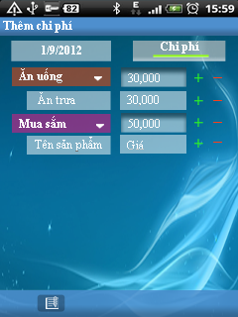
Screen:

USE CASE- Edit Expense or Income SPECIFICATION

Use-case No. | UC001.3 | Use-case Version |  | 1.0
Use-case Name | Edit expense or income
Author | LinhLLL
Date | 03/10/2012 | Priority | High
Actor:
User
Summary:
User can edit detail expense which they added.
Goal:
Allow user edit expense.
Triggers
Touch first icon at the bottom of screen
Preconditions:
Accessed to application
Post Conditions:
<List the required post-conditions for using this case>
Main Success Scenario:

Step | Actor action | System response
1 | Touch first icon at the bottom of screen | Display “Chi phí” screen includes list of expense
2 | Choose one item of list expense on screen | Display view detail screen
3 | Touch edit icon at the top- right of screen | Display edit screen
4 | Edit data in all fields | All data is changed
5 | Touch save icon at the top- right of screen | - Return view detail screen  - Show message “Saved”  - Display saved data

Step | Actor action | System response
1 | Touch first icon at the bottom of screen | Display “Chi phí” screen
2 | Choose one item of list expense on screen | Display view detail screen
3 | Touch edit icon at the top- right of screen | Display edit screen
4 | Edit data in all fields | All data is changed
5 | Touch cancel icon beside save icon | - Return view detail screen  - No data is edited

Alternative Scenario:
Step | Actor action | System response
1 | Touch first icon at the bottom of screen | Display “Chi phí” screen includes list of expense
2 | Choose one item of list expense on screen | Display view detail screen includes detail information of expense
3 | Touch edit icon at the top- right of screen | Display edit screen
4 | - Touch “Chi phí” toggle  - Edit data in all fields | - Change “Chi phí” to “Thu nhập” toggle  - All data is changed
5 | Touch save icon at the top- right of screen | - Return view detail screen  - Show message “Saved”  - Display saved data

Exceptions: N/A
Relationships:
UC 001.1,UC 001.2, UC 001.4
Business Rules:

No | Rule Description
1 | In order to edit expense/income, user must accessed application
2 | In order to edit expense/income, “Chi phí”/ “Thu nhập” screen must have at least one schedule
3 | In order to save what user edited, user must enter data into mandatory field

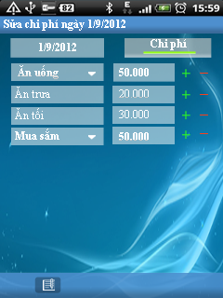
Screen:

USE CASE- Delete Expense or Income SPECIFICATION

Use-case No. | UC001.4 | Use-case Version |  | 1.0
Use-case Name | Delete expense or income
Author | LinhLLL
Date | 03/10/2012 | Priority | High
Actor:
User
Summary:
User can delete expense or income.
Goal:
Allow user delete expense or income.
Triggers
Touch first icon at the bottom of screen.
Preconditions:
Accessed to application
Post Conditions:
<List the required post-conditions for using this case>
Main Success Scenario:

Step | Actor action | System response
1 | Touch first icon at the bottom of screen | Display “Chi phí” screen
2 | Long click on one item in list expense | Display menu includes:  - “Thêm mới”  - “Chỉnh sửa”  - “Xóa”
3 | Touch “Xóa” | Show pop-up confirm includes:  - Message: “Bạn muốn xóa khoản chi này không?”  - 2 buttons: “Có” and “Không”
4 | Touch “Có” button | - Clear expense  - Show message: “Đã xóa”

Step | Actor action | System response
1 | Touch “Schedule” tab | Display “Chi phí” screen
2 | Long click on one schedule | Display menu includes:  - Thêm mới  - Chỉnh sửa  - Xóa
3 | Touch “Xóa” | Show pop-up confirm includes:  - Message: “Bạn muốn xóa khoản chi này không?”  - 2 buttons: “Có” and “Không”
4 | Touch “Không” button | - Return “Chi phí” screen

Alternative Scenario:
Step | Actor action | System response
1 | Touch first icon at the bottom of screen | Display “Chi phí” screen
2 | Touch “Thu nhập” tab | Display “Thu nhập” screen
3 | Long click on one item in list income | Display menu includes:  - “Thêm mới”  - “Chỉnh sửa”  - “Xóa”
4 | Touch “Xóa” | Show pop-up confirm includes:  - Message: “Bạn muốn xóa khoản thu này không?”  - 2 buttons: “Có” and “Không”
5 | Touch “Có” button | - Clear income  - Show message: “Đã xóa”

Exceptions:
Relationships:
UC 001.1, UC 001.2, UC 001.3
Business Rules:
No | Rule Description
1 | In order to delete schedule, user must accessed application
2 | In order to delete schedule, “Schedule” screen must have at least one schedule

Screen:

